Projects

1.
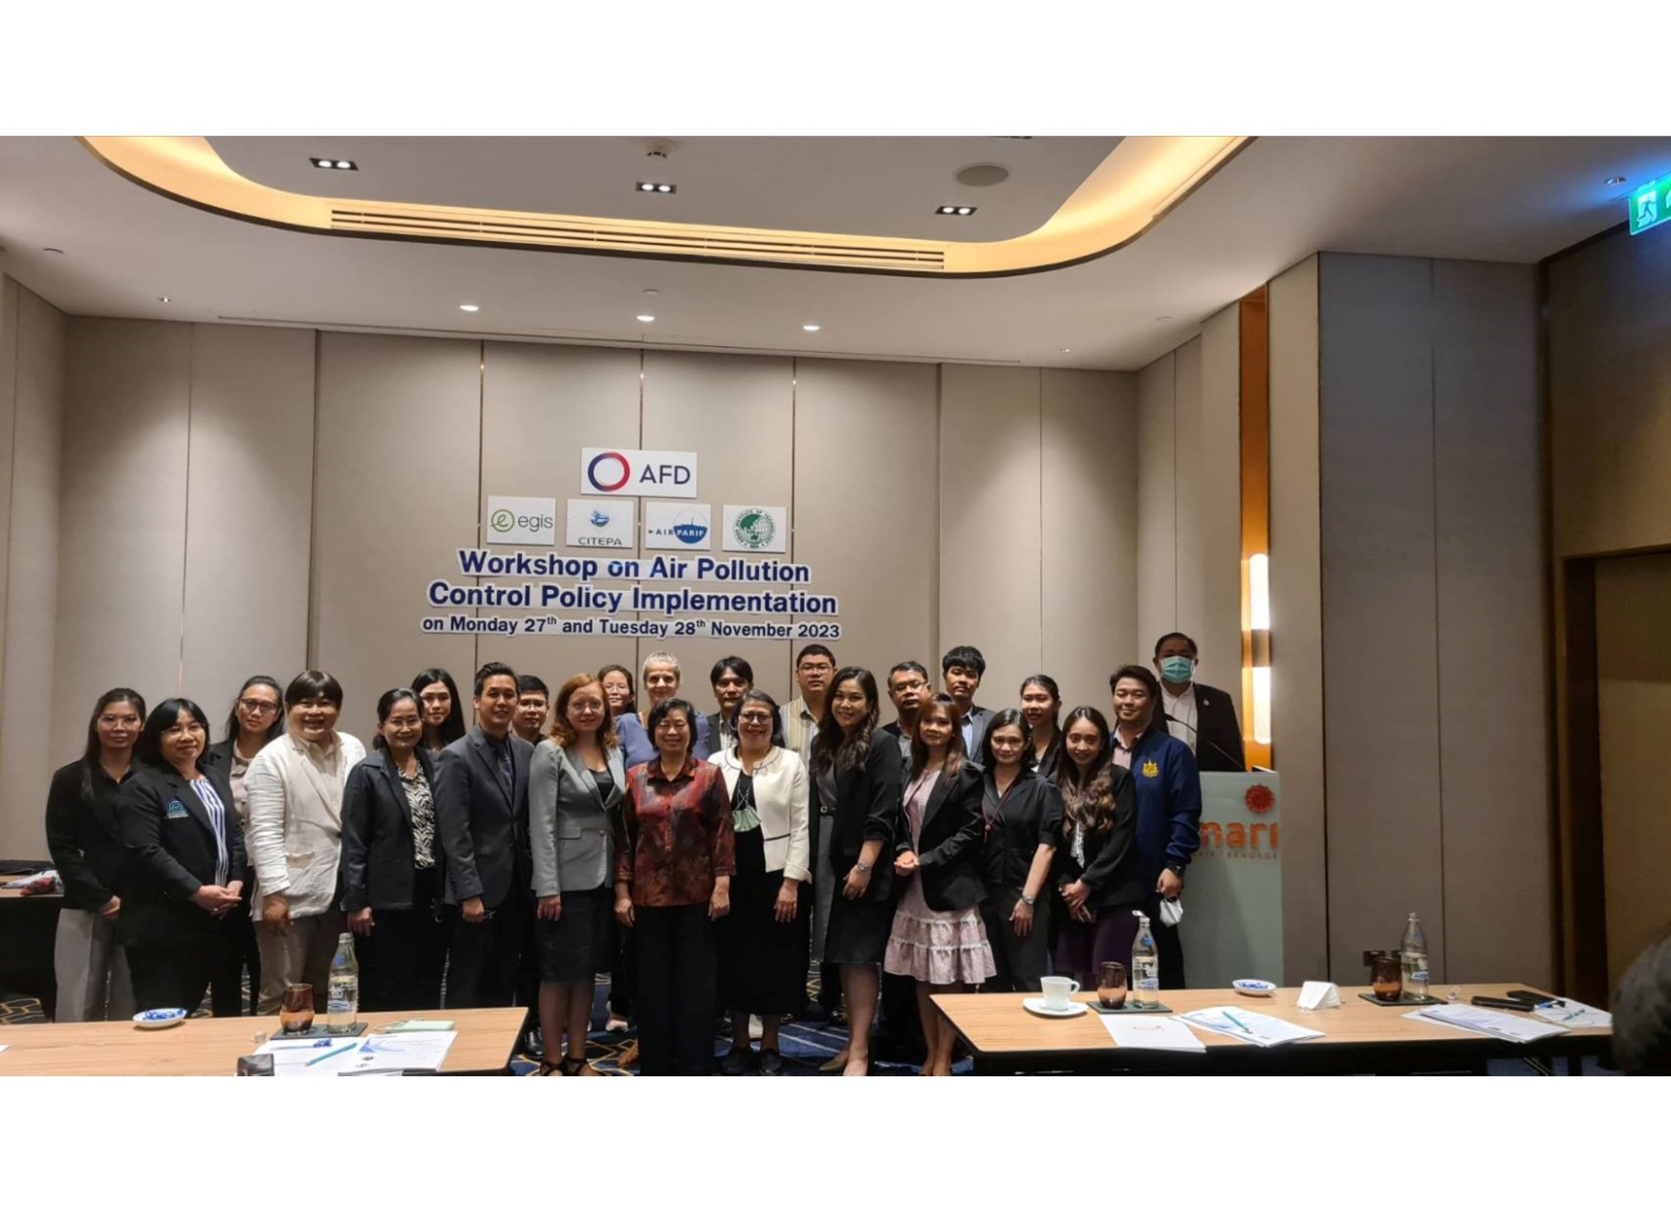
Air Quality Improvement Program in Thailand (AQIP-Thailand)
Funding: Agence Française de Développement (AFD) | Duration: 2023-2026
Partners:
Egis, AirParif, Citepa
Objectives:
The overall objective of this project is to support Thailand and at the local scale by supporting Chiang Mai provinces in their efforts to develop and implement policies and projects in order to improve air quality.
The specific objectives of the project are:
- To strengthen the current air quality management system;
- To build up the capacities and sharp competencies of local Thai agencies;
- To provide technical support and recommendations to implement “quick win” measures to reduce air pollution;
- To assess the feasibility of the introduction of zero-emission vehicles such as electric bus in a widespread urban area;
- To have a better knowledge and monitoring of the air quality
Overall work packages:

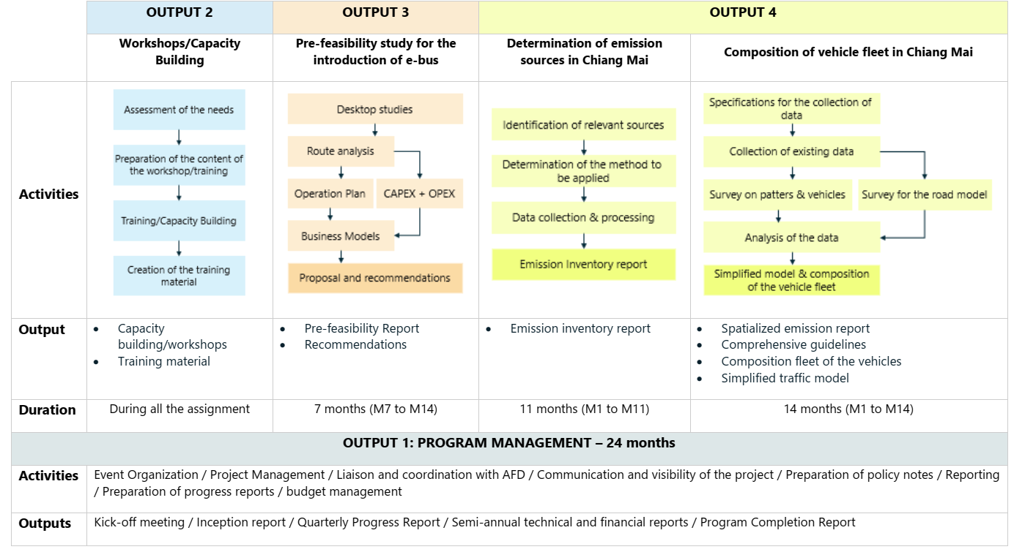
Key Activities:
- Strengthening of the air quality management system
  - Audit of different existing emission inventories and modelling tools: This task assesses the needs of the Pollution Control Department (PCD) in terms of capacity building on emission inventory, on modelling tools, and to adapt the training sessions to their needs.
  - Critical analysis of the existing tools: The conclusions of the audit (1.1) are presented in a document including a mapping of the existing tools and short- and medium-term improvements.
  - Based on the results of the audit of the existing emission inventory and modelling tools, provide the capacity building sessions for the PCD on emission inventory and modelling tools.
  - Training capacity building sessions for the PCD on the tools and methods to assess the spatial representativeness of monitoring stations.
  - Organize workshops to address the spatial representativeness of stations of the existing PCD’s network.
  - Guidelines to assess the spatial representativeness of the PCD’s monitoring network.
  - Training sessions for the PCD on the environmental data integration tools and related statistical models for the calculation of the population-mean annual exposure.
- Capacity-building at the national/regional scale
  - Organization of a study tour on the articulation of air quality management at the local, national, and regional scales.
  - Organization of workshop to define the future role of the PCD and other organizations.
- Support to develop activities led by the Office of Transport and Planning (OTP)
  - Capacity building to the three Ministries on European regulation, implementation, and enforcement of emission standards for on-road vehicles and industrial sites.
  - Support to the Ministry of Transport in the drafting of the decree aiming at accelerating the renewal of the vehicle fleet towards the Euro 5 and Euro 6 norms.
  - Planning for the deployment of electric buses in Chiang Mai.
- Support to develop activities led by Chiang Mai Municipalities
  - Compilation of emission inventory for key sources in Chiang Mai province.
  - Conducting surveys for assessing the composition of the vehicle fleets in Chiang Mai.

Events
Name | Brief Info | photo | Date. Place. Link with the events
Field trips/visits
Name | Brief Info | photo | Date. Place. Link with the events
 | 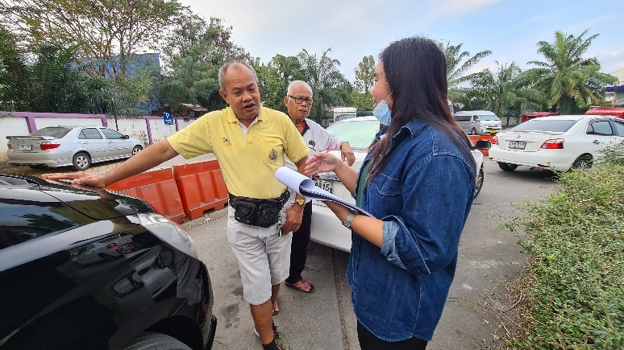 | 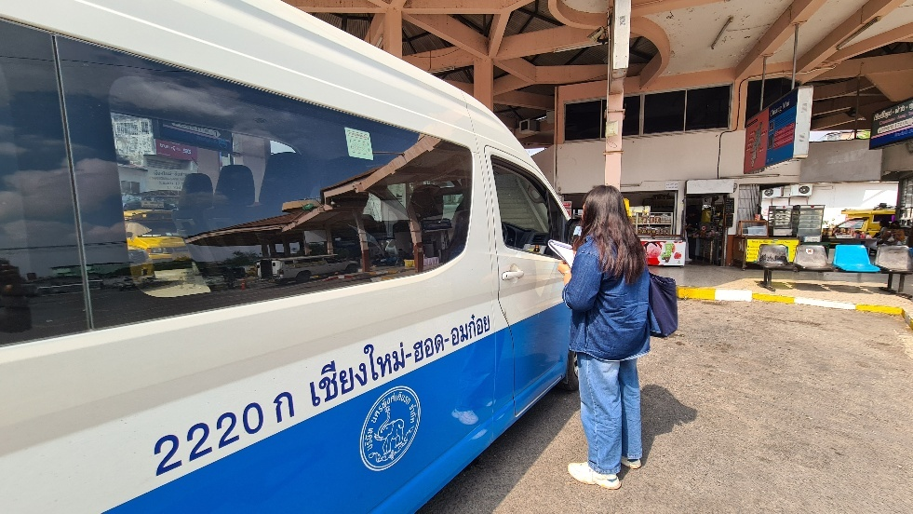
 | 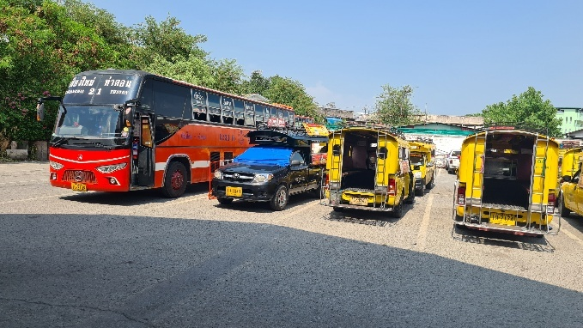\  Field visit to a terminal in Chiang Mai | 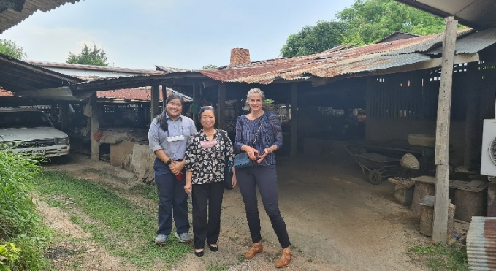  Field visit to a craft village in Chiang Mai
Publications
Name | Brief Info | photo | Date. Place. Link with the events
Air quality improvement program in Thailand (AQIP): Report on Comprehensive Inventory Methodology Report for Chiang Mai Province, Thailand (2022). | A Spatialized emissions inventory was built for the Province of Chiang Mai. This report gives the detailed methodology used, the activity, the emission factors as well as the methodology for spatial attribution of the emissions for each sector. This methodology report aims at being a reference for emissions inventory building and should be the base for a regular update and improvement of the Chiang Mai Emissions Inventory (EI). | 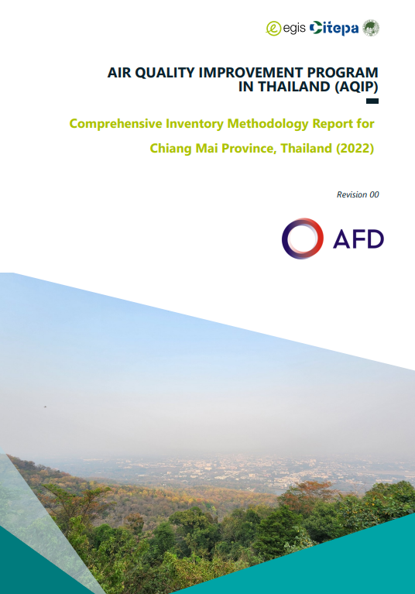 | Available at Comprehensive Inventory Methodology Report for Chiang Mai Province, Thailand
Air quality improvement program in Thailand (AQIP): Roadmap Emission Sources and Policies Report. | As part of the AQIP programme, an integrated gridded emission inventory has been developed for Chiang Mai province of Chiang Mai. This integrated emission inventory is the first one developed in the province and even in Thailand with such characteristics. A set of air pollutants and GHGs are covered in a consistent method. The Gridded emission inventory details the location and magnitude of emissions across Chiang Mai province for the year 2022. The development of this inventory employed the most suitable methodologies, drawing on EMEP/EEA, IPCC guidelines, ABC-EIM and relevant scientific literature. Emission calculation for road transport is based on a traffic survey and modelling conducted by EGIS, which offers a better description of the in-use vehicle fleet composition (passenger cars, light duty vehicles, heavy-duty vehicles and two-wheel vehicles) and traffic pattern. This modeling enables accurate assessment of kilometers driven per vehicle type and along major roads | 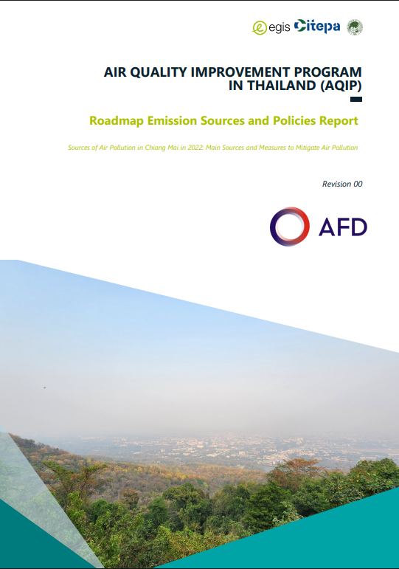 | Available at Roadmap Emission Sources and Policies Report
Air Quality Improvement Program in Thailand (AQIP): Booklet on Sources of Air Pollution in Chiang Mai in 2022 - Main Sources and Measures to Mitigate Air Pollution. | Abstract  As part of the AQIP project, an integrated gridded emission inventory has been developed for the province of Chiang Mai. This integrated emission inventory is the first one developed in the province. A set of air pollutants and GHGs are covered in a consistent method. The Gridded emission inventory details the location and magnitude of emissions across Chiang Mai province for the year 2022. To build this integrated air pollutants and GHGs inventory, the most appropriate methodologies were used based on EMEP/EEA, IPCC, and scientific papers/reports. Calculation of road transport emissions is based on a traffic survey and modelling carried out by EGIS that provide a better description of the composition of the vehicle fleet in circulation, and of traffic per vehicle type (passenger cars, light duty vehicles, heavy-duty vehicles and two-wheel vehicles). Road transport modelling by EGIS allows to assess the kilometers driven per vehicles and per main roads. For other sectors, agriculture, waste, industrial processes and product use (IPPU) and energy, cooperation between AIT and Citepa has enabled to collect the most appropriate data for the province. Nevertheless, in some cases when adequate data were not available, simplifications or assumptions were necessary. A detailed description of the methodology developed, and work plans for improving the inventory step by step are provided in a methodological guide: "Comprehensive Inventory Methodology Report for Chiang Mai Province,Thailand (2022)". It is crucial to maintain and regularly update this emission inventory on a periodic basis as it is a key instrument to defines policies and measures in the different sectors and measure the progress made from year to year in terms of emission reductions. The key emission sources of the different pollutants and GHG were identified. For particulate matters (the main air quality problem in the province) and their precursors (SO2, NOx, NH3) the main sources are: open biomass burning, road transport, agriculture, and the residential/commercial sectors. This report proposes several measures to reduce the impact of transport emissions, such as reducing the number of old heavy vehicles (buses, coaches, and trucks), which would significantly lower fine particulate emissions and NOx. Incentives to accelerate the renewal of passenger car and light-duty vehicle fleets would be effective, particularly following the release of the decree on Euro 5 vehicle and fuel standards in January 2024. Euro 5 vehicles are equipped with particle filters that substantially reduce emissions. Additionally, promoting walking, cycling, and public transportation can reduce not only air pollution but also GHG emission, noise pollution and urban heat islands. Modal shift is also one of the most efficient ways, with electric mobility, to reduce CO2 emissions. This is especially relevant as road transport is the main source of CO2 emissions in the province. |  | Available at Air Quality Improvement Program in Thailand: Sources of Air Pollution in Chiang Mai in 2022 - Main Sources and Measures to Mitigate Air Pollution
Media
Name | Brief Info | photo | Date. Place. Link with the events

Gallery:
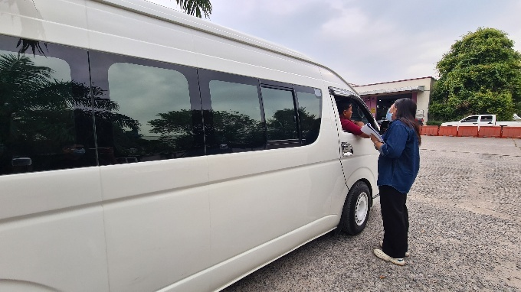  A student asked for vehicle information from a van driver in Chiang Mai | 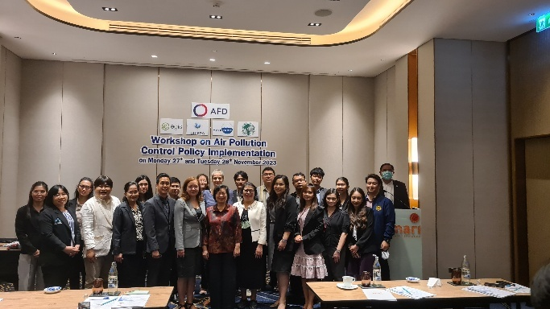  Workshop on Air Pollution Control Policy Implementation on 27-28 November 2023

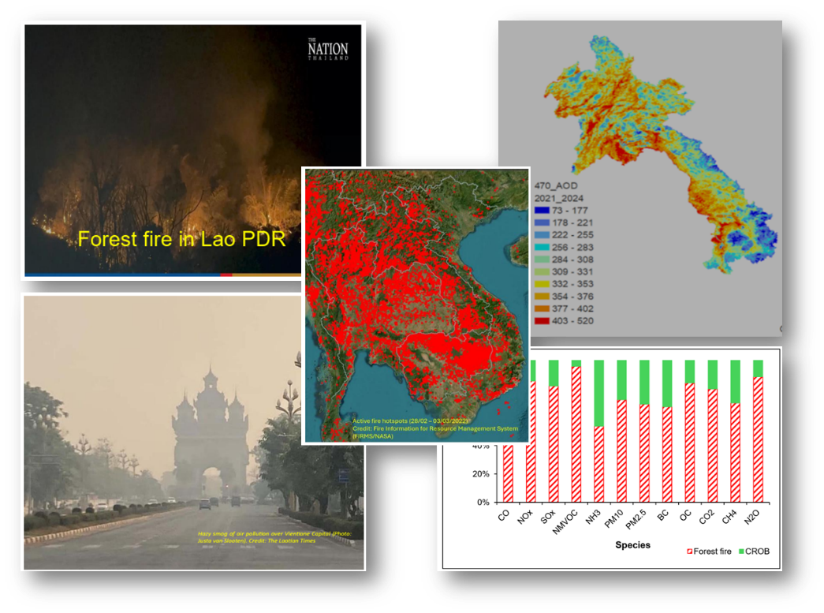
Assessment of agricultural and forest burning emissions in Lao PDR (Forest Fire Emission- Lao)
Finding: The World Bank Group (WBG) | Duration: 2025
Objectives:
This study aims to analyze the biomass open burning (BOB) situation and its association with air pollution emissions and ambient levels in the Lao PDR by using information from several data sources and the application of technical tools.
The specific objectives and main activities performed of the objectives are as presented below.
- To understand the context of BOB in Lao PDR in conjunction with other countries in mainland Southeast Asia, an extensive literature review of swidden agriculture, BOB types, BOB emissions (forest fires and crop residue open burning [CROB]) in the region, and transboundary air pollution is required.
- To investigate the air pollution levels in the Lao PDR, both spatial (national, zone, and provinces) and temporal distribution (annual, seasonal, and monthly), by using satellite products of hotspots and relevant air pollution indicators for 2022, 2023, and 2024. This task involves the deployment of a consistent methodology with the FAO’s study (Tattaris and others 2023) and obtains decadal time series of the parameters, 2015-2024, for similar columnar parameters of Aerosol Optical Depth (AOD), O₃, SO₂, NO₂, Ultra-violet Aerosol Index (UVAI), and active fire hotspots.
- To quantify the emissions from BOB, focusing on forest fires and CROB. This task involves 3 sub-tasks:
- Compilation and scrutinization of the available emission factors (EFs) of forest fires and CROB for key air pollutants (CO, SOx, NOx, NMVOC, NH₃), PM₁₀, PM_{2.5}, and short-lived climate forcers (SLCFs) of BC, OC, and GHGs (CO₂, CH₄, N₂O). This study gives priority to the local measurement EFs in the country and in Southeast Asia.
  - Compilation of the activity data and development of an emission inventory (EI) for BOB, including forest fires and CROB, in the Lao PDR for 2022. The emission estimates cover the key air pollutants, PM, SLCFs, and GHGs.
  - Application of QA/QC to ensure the quality of EI data. This study conducted QA/QC measures, including QA/QC of the activity data and EFs. The emissions estimates produced by this study are compared and evaluated against other available databases for 2022.
- To develop a methodology framework for analyzing the change in forest land cover (forest loss) and the gain/change in agricultural land cover in association with forest fires. This task involves developing and testing a method for a forest fire-prone area of the North zone of the Lao PDR.
- To provide a menu of recommendations, based on the findings in the previous tasks, prioritizing BOB emission control measures that lead to air quality improvements and simultaneously mitigate emissions of climate forcers of GHGs and SLCFs.

Research Overall Methodology:

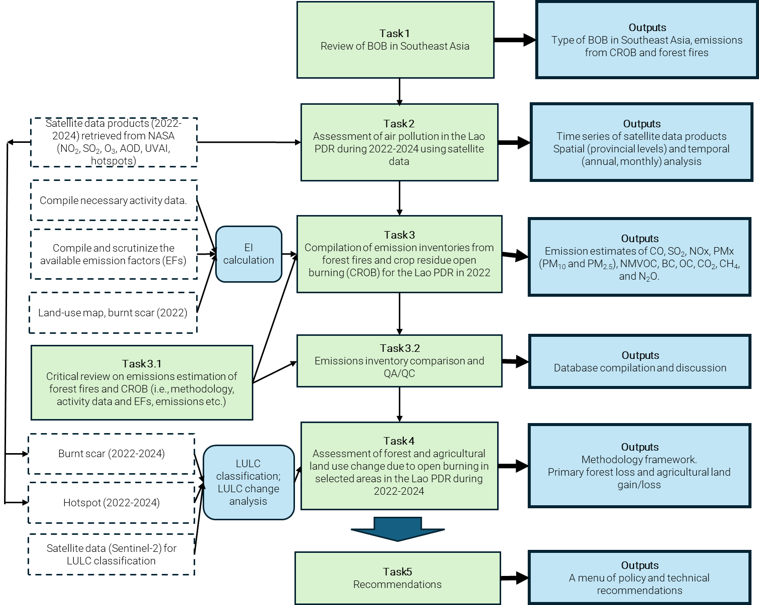

Events
Name | Brief Info | photo | Date. Place. Link with the events
Field trips/visits
Name | Brief Info | photo | Date. Place. Link with the events
Publications
Name | Brief Info | photo | Date. Place. Link with the events
Media
Name | Brief Info | photo | Date. Place. Link with the events

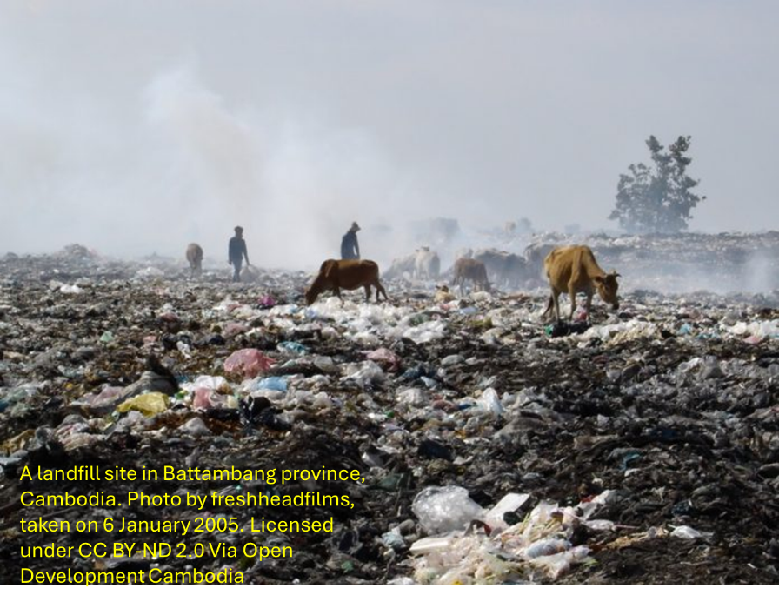
Deliver training programme for implementing decrees for reducing open waste burning and air pollution
Finding: Climate and Clean Air Coalition, United Nations Environment Programme | Duration: 2025-2027
Partners:
Clean Air Asia, Ministry of Environment of Cambodia
Objectives:

The overall objective of this project is to support Cambodia in effectively reducing open burning and improving air quality through an action plan and training program. Clean Air Asia will merge its strengths in stakeholder engagement, capacity building, and science-based policy guidance with AirQC technical expertise in air quality and solid waste management and data analysis to effectively implement this project with the Ministry of Environment of Cambodia.

Outcomes:

- Federal, provincial, district, communal, and village level authorities have strengthened their capacity to enforce regulations for reducing municipal waste open burning, and air pollution
- By project completion or soon after, the national government of Cambodia endorses an action plan to reduce all types of waste burning to meet its 50 per cent reduction target by 2030.

Outputs:

Output 1:
  - Training needs assessment of federal, provincial, district, communal, and village level authorities regarding the ban for open waste burning and requirements for enforcement.
  - Training modules and materials covering the regulations, including enforcement procedures, developed for enforcement authorities.
  - Technical guidelines on alternatives to municipal waste open burning are developed.
  - Training-of-Trainers delivered to participants in the selected provinces.

Output 2:
2.1 Detailed action plan to reduce municipal waste open burning.
2.2 Consultation meetings with federal, provincial, district, communal, and village level authorities regarding the ban on municipal waste open burning and requirements for enforcement.

Key Activities:

1.1.1 Conduct stakeholder mapping and Knowledge, Attitude, and Practices (KAP) survey for stakeholders at various levels of the government.
1.2.1 Develop training modules based on the KAP survey results, existing resources from the CCAC Air Quality Management Exchange (AQMx) platform, and other related materials.
1.3.1 Develop a technical guideline outlining alternatives to open burning based on the results of the KAP survey and desk research of best practices and case studies.
1.4.1 Conduct a one-day Training-of-Trainers using the training materials and modules, and technical guidelines.
1.4.2 Conduct regular online technical sessions to support the one-day Training-for-Trainers.
2.1.1 Compilation, analysis, and discussion meeting on the knowledge database on the air pollution and short-lived climate pollutants (SLCP) emission profile of waste management strategies.
2.1.2 Facilitate visioning and target setting for the action plan.
2.1.3 Conduct a prioritization workshop to determine the content of the action plan.
2.1.4 Develop the detailed action plan.
2.2.1 Conduct a consultation meeting to present and validate the first draft of the action plan.
2.2.2 Conduct a project closing event to present the finalized action plan.

Events
Name | Brief Info | photo | Date. Place. Link with the events
Field trips/visits
Name | Brief Info | photo | Date. Place. Link with the events
Publications
Name | Brief Info | photo | Date. Place. Link with the events
Media
Name | Brief Info | photo | Date. Place. Link with the events

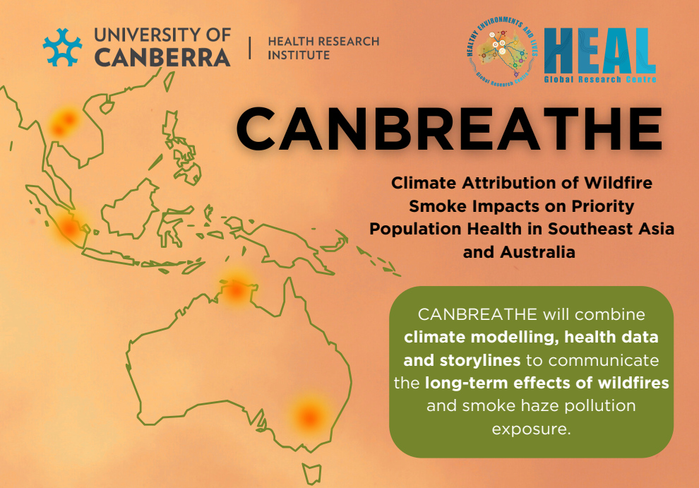
Climate Attribution of Wildfire Smoke Impacts on Priority Population Health in Southeast Asia and Australia (CANBREATHE)
https://healnetwork.org.au/projects/canbreathe/
Finding: Wellcome Trust | Duration: 2025-2028
Partners:
Host: University of Canberra (Australia),
Collaborating Parties: Australia (University of Tasmania, University of Sydney, Charles Darwin University, Queensland University of Technology, Curtin University, and NSW Department of Climate Change, Energy, the Environment and Water), Thailand (Air Quality Nexus Center at AIT, Mahidol University, Chiang Mai University, Climate Change and Environmental Research Center, and Geo-Informatics and Space Technology Development Agency), Indonesia (Climate Change Research Centre, University of Indonesia, Institute of Technology National in Bandung, and Kopernik), Lao PDR (National University of Laos and University of Health Sciences of Laos), Cambodia (The Institute of Technology of Cambodia), and Greece (Technical University of Crete), and International Organization (Jagun Alliance Aboriginal Corporation)

Project Description:
Climate change is increasing the frequency, intensity, and duration of extreme wildfires and smoke haze pollution in Southeast Asia and Australia, exacerbating respiratory and cardiovascular illness, and contributing to thousands of premature deaths. Severe smoke haze from wildfires in Sumatra, Indonesia, in 2015 resulted in around 100,000 excess deaths. In Australia, smoke from the 2019/20 Black Summer wildfires was associated with 417 deaths. Although current impact estimates highlight the public health challenge posed by wildfires, they do not specifically attribute the impacts of wildfire smoke to climate change. Nor do they specifically focus on sensitive population groups disproportionally affected by climate change.

This international three-year research project (2025-2028), led by the HEAL Global Research Centre at the University of Canberra, includes five case studies from Australia, Thailand, Indonesia, and Laos. The project engages policymakers, Indigenous peoples and communities, citizen scientists and artists in the participatory co-design of innovative communication tools based on air pollution and climate attribution science, health impact data, and the culture and lived experiences of communities suffering extreme or recurrent wildfires in Thailand, Laos, Indonesia, and Australia.

Objectives:

This transdisciplinary research project CANBREATHE, involving partners from Australia, Thailand, Indonesia, and Laos, aims to assess and communicate the health impacts of wildfire smoke attributable to anthropogenic climate change in five heavily affected regions of Southeast Asia and Australia, in order to inform climate and health policy and empower disadvantaged populations.
The specific objectives are to:
- Estimate the burden of wildfire smoke on population health under current and future conditions.
- Understand and influence public perceptions of wildfire health impacts and association with climate change, particularly among disadvantaged and priority populations.
- Build skills and resilience, using innovative and impactful communication techniques.
- Inform and influence climate and health policy development through deep engagement with key policy stakeholders and targeted communication.
- Strengthen cross-sectoral engagement and collaboration across Southeast Asia and Australia, to build capacity and capability for assessing and communicating wildfire smoke impacts.
Project’s overall framework:
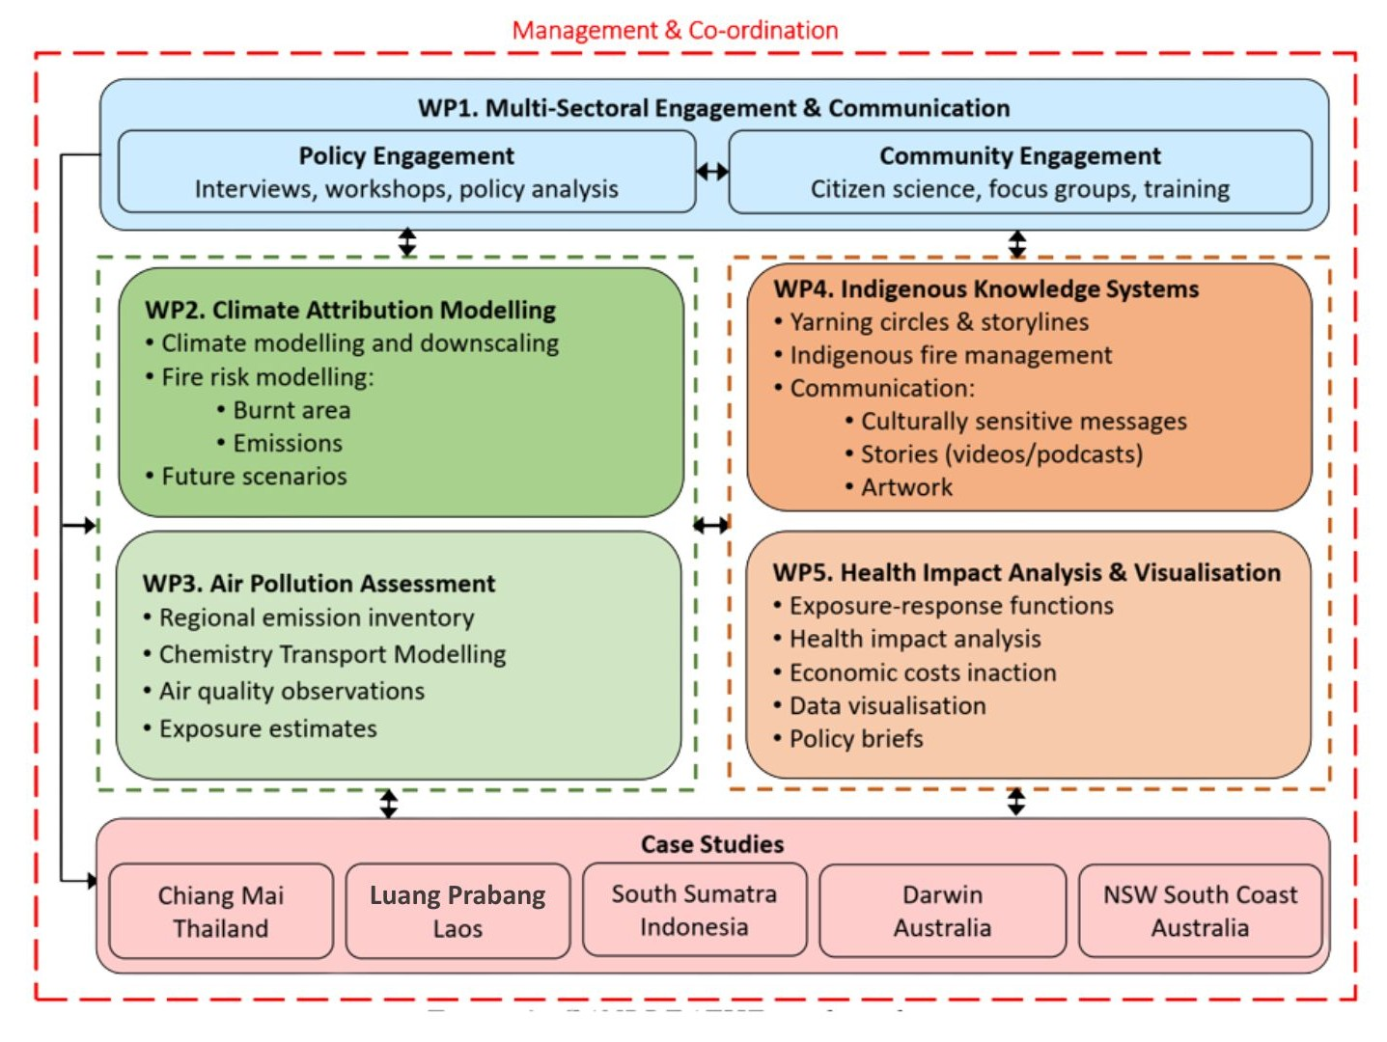
Details of Work Packages

WP1: Multi-Sectoral Engagement & Communication
Task 1.1 Policy engagement and prioritization
- Systematically map climate and health, wildfire smoke prevention, and health protection policies for priority populations in Southeast Asia and Australia.
- Conduct in-depth interviews with key policymakers.
- Organize four policy dialogues in national capitals, hold co-design workshops to identify and prioritize evidence needs, and organize four integration workshops on translation and implementation.
Task 1.2 Community engagement and co-design
- Use a cross-sectional approach to assess community perceptions of climate change and its
health impacts, and related environmental health literacy needs.
- Conduct in-depth interviews with community leaders, Indigenous rangers, and health practitioners, and focus group discussions (FGDs).
Task 1.3 Citizen science and community empowerment
- Install low-cost air quality sensors at 60 households (in each region) to illustrate community exposure to wildfire smoke.
- Demonstrate construction of DIY air purifiers and provide the necessary materials.
WP2. Climate Attribution Modelling
Task 2.1 Climate modelling with/without anthropogenic forcing
- Perform a combined data analysis and modelling study, using ‘end-to-end’ attribution
assessment, based on the World Weather Attribution group’s probabilistic extreme event
attribution analysis methods.
- Perform large ensembles of climate model simulations from at least three Coupled Model Intercomparison Project Phase 6 (CMIP6) models. The simulations will represent three climate scenarios: (A) unperturbed pre-industrial with natural forcing only, (B) current with anthropogenic forcing, and (C) future close to the 2°C warming threshold (SSP2-4.5 by 2070).
Task 2.2 Wildfire emissions and burnt areas
- Calculate burnt area and wildfire emissions for the three scenarios using the INFERNO global fire model.
- Compare and scale using emissions estimates for specific wildfire events will be obtained from the Global Fire Emissions Database (GFED3) and other satellite products.
WP3: Air Pollution Assessment
Task 3.1 Air pollution modelling
- Apply the Weather Research and Forecasting (WRF) model coupled with selected chemical transport models (CTM), i.e., CMAQ and Chem/CAMx, to assess regional and urban-scale air quality, respectively.
- Evaluate model performance for current climate simulations using ground-level measurements.
WP4: Indigenous Knowledge Systems
Task 4.1 Storylines, connection to Country and health equity
- Systematically engage Indigenous peoples and organizations in: (a) assessing wildfire
impacts on Indigenous communities, (b) exploring Indigenous forest fire management practices in the climate change context, and (c) integrating Indigenous knowledge structures into storylines comprising Indigenous knowledge traditions, to shape climate and health policy.
- Organize culturally safe yarning circles (informal focus groups) that tease out information
through storytelling.
Task 4.2 Climate and health communication
- Develop culturally sensitive climate and health messaging for Indigenous peoples, and produce four videos/podcasts communicating strength-based Indigenous approaches to fire management, caring for Country, climate change adaptation and health.
- Prepare commission Indigenous artwork and run school poster competitions.
WP5: Health Impact Analysis, Valuation & Visualization
Task 5.1 Health impact analysis and attribution
- To quantify quantitative health impact assessments (HIAs), including uncertainty analysis for estimating: (a) current and future wildfire smoke impacts with/without climate change, (b) cause-specific health burdens for children at birth and 0-5 years (stillbirth, preterm birth, fetal growth restriction), and for pregnant women (e.g. gestational hypertension).
Task 5.2 Economic cost of health impacts
- Review economic policy instruments used to constrain slash-and-burn agriculture and
deforestation, and facilitate Indigenous practices for wildfire prevention.
- Perform an economic valuation using our cost-of-illness method, including hospitalization,
mortality and lost productivity associated with smoke exposure.
Task 5.3 Data visualization and dissemination
- Develop an innovative relational geospatial database to store wildfire smoke exposure and health indicators.
- Develop an online interactive dashboard for retrieving database information and visualizing smoke- and health-related indicators.

Key Deliverables/Activities/Achievements:
Template: Name of event/deliverables. Date. Place. Link with the events.
- Events
- Field trips/visits
- Publications
- Media
- Others

View details => same information as above
View Details

Events
Name | Brief Info | photo |  |  | Date. Place. Link with the events
Regional Policy Dialogue Workshop in Vientiane, Lao PDR | On 26th June 2025, Prof. Kim Oanh and Dr. Lai Nguyen Huy, participated in a high-level regional policy dialogue in Vientiane, Lao PDR, which was co-hosted by the University of Canberra (Australia), National University of Laos, and the University of Health Sciences Laos.  The workshop brought together over 40 delegates to introduce two projects for which the Air Quality Nexus Center is the key partner: Climate change adaptation to smoke haze for improved child health in Southeast Asia (HEAL-HAZE) and Climate Attribution of Wildfire Smoke Impacts on Priority Population Health in Southeast Asia and Australia (CANBREATHE).  The workshop provided key opportunities to understand the social, political and economic barriers to mitigation which empowered the health sector to deal with smoke-haze from biomass open burning. | 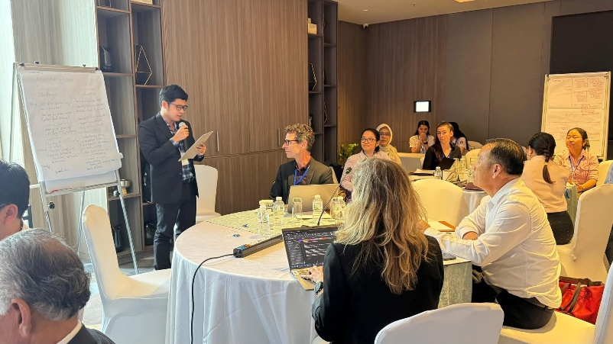  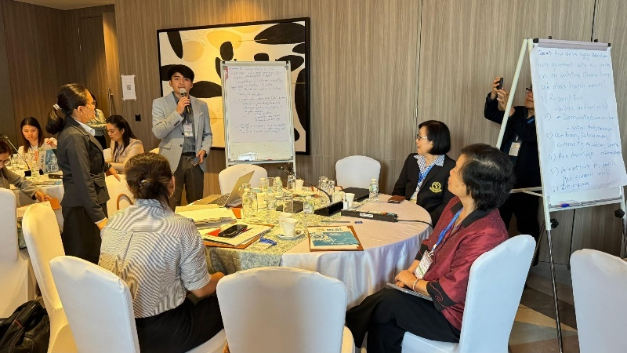  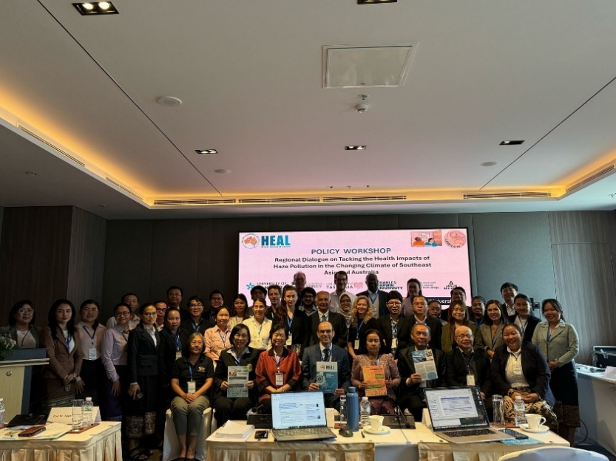 |  | 26 June 2025
Policy Dialogue Workshop on Tackling the Health Impacts of Haze Pollution in Southeast Asia and Australia in Bangkok, Thailand | Policy dialogue is an important work package of HEAL-HAZE and CANBREATHE. The AirQC team (Prof. Kim Oanh and Dr. Lai Nguyen Huy) participated in the policy dialogue workshop on “Tackling the Health Impacts of Haze Pollution in Southeast Asia and Australia” held in Bangkok, Thailand on 17th June 2025.  This joint workshop aimed to engage policymakers and other stakeholders to prioritize solutions against haze pollution for affected communities and schools, co-create a platform for policy dialogue and knowledge exchange, and identify opportunities for regional cooperation on tackling the health impacts of air pollution and climate change.  Prof. Kim Oanh, Center Director, delivered a keynote presentation on “Overview of Smoke Haze Pollution from Wildfires and Agricultural Burning in Southeast Asia”. The AirQC team actively participated in the discussion groups which aimed systematically map existing interventions and policies; engage multi-sectoral stakeholders to prioritize adaptation solutions; Identify implementation challenges, barriers, and enablers; co-design adaptation interventions tailored to regional needs; Empower health sector to deal with smoke haze; and understand the social, political and economic barriers to mitigation. | 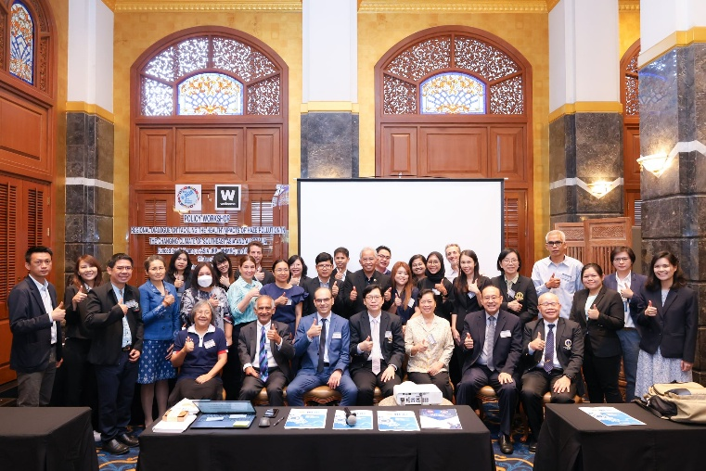 |  | 17 June 2025
Regional Policy Workshop “Tackling the Health Impacts of Haze Pollution in Southeast Asia and Australia” | The AirQC team participated in the Regional Policy Workshop “Tackling the Health Impacts of Haze Pollution in Southeast Asia and Australia”, organized by the HEAL-HAZE and CANBREATHE projects.  The event aims to engage policymakers and other stakeholders to prioritize solutions against haze pollution for affected communities and schools, co-create a platform for policy dialogue and knowledge exchange, and identify opportunities for regional cooperation on tackling the health impacts of air pollution and climate change.  In her role as a panelist, Prof. Kim Oanh provided insights in the section of “Regional cooperation on tackling health effects of forest fire”. She shared on the need for regional collaboration to reduce the biomass open burning and associated transboundary air haze phenomena. |  |  | 24th September 2025
Public Seminar “ENVIFAIR 2025 X RCCC UI” at the University of Indonesia, 25th September 2025 | The Faculty of Public Health (FPH) Universitas Indonesia (UI), in collaboration with the Research Center for Climate Change (RCCC) UI, held the International Environmental Health Seminar Envifair 2025 X RCCC UI at the Universitas Indonesia Convention Hall, Depok. Carrying the theme “Breathing Clean, Living Green: Achieving Net-Zero Emissions Towards Different Sectors,” the seminar served as an important forum to seek solutions for Indonesia’s ongoing air quality crisis.  The AirQC team participated in the Public Seminar “ENVIFAIR 2025 X RCCC UI”, which was organized by the Research Center for Climate Change (RCCC) and Faculty of Public Health, Universitas Indonesia, Depok, as a part of the HEAL-HAZE (link) and CANBREATHE (link) projects.  Prof. Kim Oanh and Dr. Huy also provided insights in the interviews conducted by the university student union, highlighting the needs for science-based information for policy making and the AirQC activities within these two projects. | 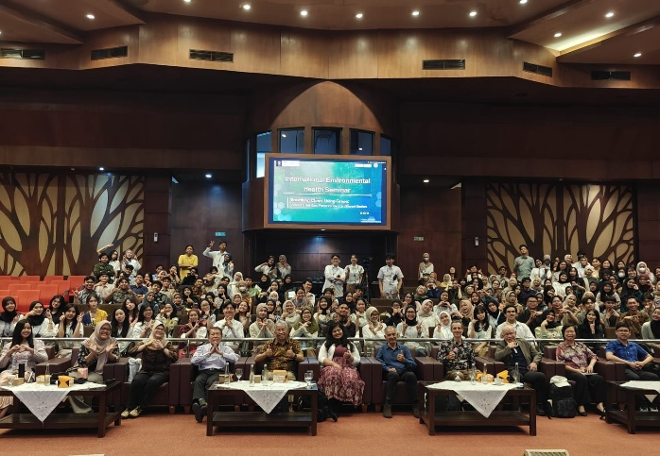 |  | 25 Sept 2025  https://fkm.ui.ac.id/en/fph-ui-and-rccc-ui-promote-global-collaboration-to-tackle-the-air-quality-emergency-at-the-2025-international-envifair/
Field trips/visits
Name | Brief Info | photo |  | Date. Place. Link with the events
Field visit and Participation in the Public Seminar at Universitas Sriwijaya, in Palembang, Indonesia, | The AirQC team (Prof. Kim Oanh and Dr. Lai Nguyen Huy) joined the international partners of Climate change adaptation to smoke haze for improved child health in Southeast Asia (HEAL-HAZE) and Climate Attribution of Wildfire Smoke Impacts on Priority Population Health in Southeast Asia and Australia (CANBREATHE) in the field visits to SD Muhammadiyah1 School, Bappeda Litbang, Silaberanti Community in Palembang, Indonesia to select appropriate sites for implementing the Clean Air Room Interventions.  The international team of the project conducted a public seminar at Universitas Sriwijaya. | 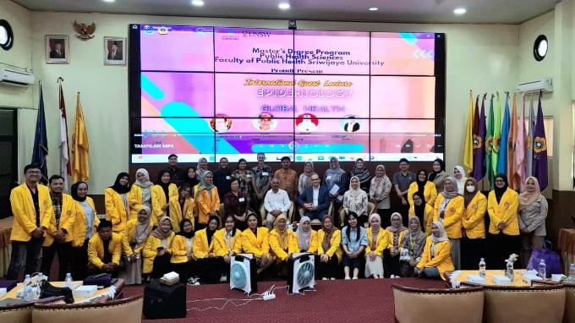 |  | 23rd September 2025
Publications
Name | Brief Info | photo |  | Date. Place. Link with the events
Media
Name | Brief Info | photo |  | Date. Place. Link with the events
Invited Speaker at 5th International Forum on Transboundary Air Pollution in Commemoration of the International Day of Clean Air for Blue Skies, 8th September 2025 | Prof. Kim Oanh, Center Director, delivered an online presentation “Wildfire emissions in Southeast Asia: multiple effects on regional air quality, ecosystem and health” at this event, which was organized by the Ministry of Foreign Affairs (MOFA), Republic of Korea.  Her presentation highlighted the need for airshed management approach to deal with the transboundary air pollution in the region. She also briefly mentioned about the research of the center within the framework of HEAL-HAZE (Climate change adaptation to smoke haze for improved child health in Southeast Asia (HEAL-HAZE) - HEAL Network) and CANBREATHE (Climate Attribution of Wildfire Smoke Impacts on Priority Population Health in Southeast Asia and Australia (CANBREATHE) - HEAL Network) projects. | 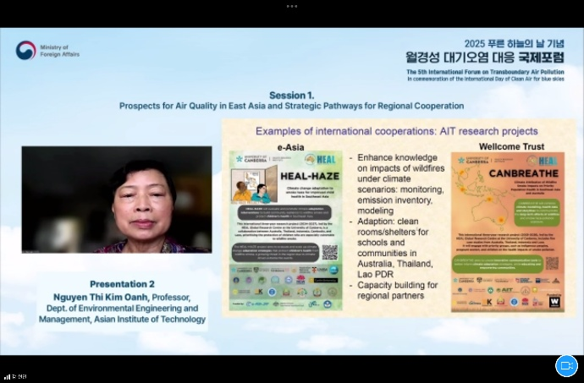 |  | The details of the event can be found at https://www.mofa.go.kr/eng/brd/m_5676/view.do?seq=322958  https://www.youtube.com/watch?v=pQFnyWl4b3Y
Public Seminar on ‘Wildfire Smoke: Health Impacts and Adaptation in Southeast Asia and Australia” | June 2025, the Air Quality Nexus Center (AirQC) hosted the public seminar on “Wildfire Smoke: Health Impacts and Adaptation in Southeast Asia and Australia”. This hybrid event brought together 28 person and 50 online participants from regional and international experts to discuss health risks from wildfire smoke and haze under climate change.  The event is within the framework of CANBREATHE and HEAL-HAZE projects. Before the public seminar happened, Dr. Lai Nguyen Huy presented an overview of the AirQC, highlighting its key research areas and projects.  The event focused on climate attribution, health assessments, and adaptation for vulnerable groups. Key presentations covered early warning systems, health effects, and interventions like clean air rooms. The seminar also promoted policy dialogue and science-based regional planning. Prof. Kim Oanh, Center Director, was also the panelist of the event, sharing her valuable insight on the situation of wildfire in Southeast Asia and its effects.  On the same date, AirQC hosted the guests to a guided laboratory tour of AIT’s research facilities, including the Environmental Engineering and Management (EEM) Ambient Laboratory, Air Quality Modeling Laboratory, and the EEM Main Laboratory. | 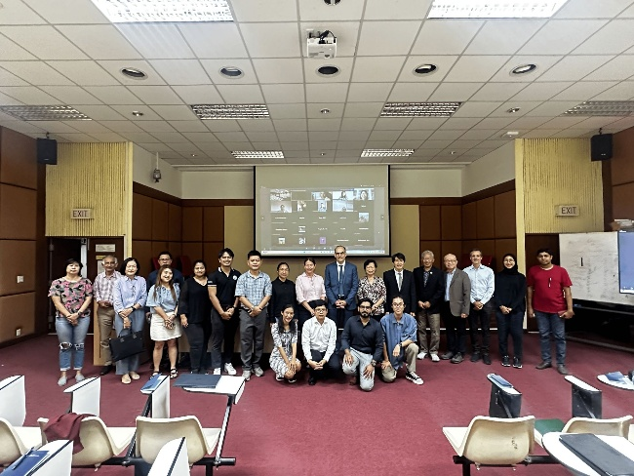  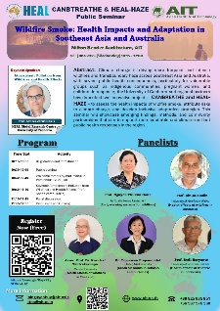 |  | 18 June, 2025

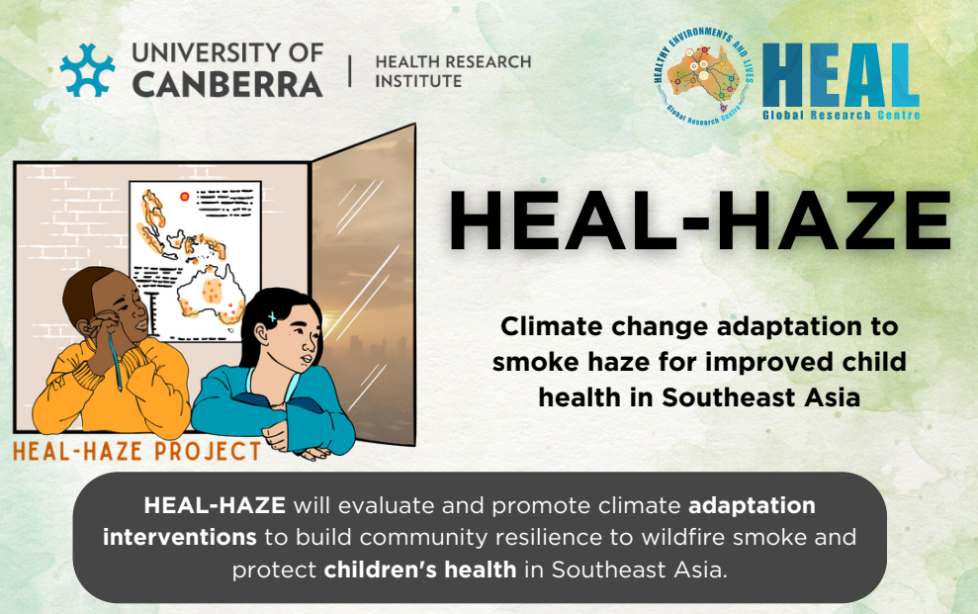
Climate Change Adaptation to Smoke Haze for Improved Child Health in Southeast Asia
https://healnetwork.org.au/projects/tackling-the-health-impact-of-smoke-haze-in-southeast-asia-heal-haze/
Funding: NHMRC e-ASIA 2023 Joint Research Program funding | Duration: 2024-2027
Partners: Australia (University of Canberra, University of Tasmania, University of Sydney, Curtin University, University of New South Wales, Commonwealth Scientific and Industrial Research Organisation, and New South Wales Health), Thailand (Air Quality Nexus Center (AirQC) at AIT, Mahidol University, Chiang May University, and Thai Pollution Control Department), Indonesia (University of Indonesia, National Institute of Technology Bandung, and Kopernik), Cambodia (Institute of Technology of Cambodia, and Cambodian Ministry of Health) and Laos (National University of Laos, University of Health Sciences, and Ministry of Health).
Objectives:
This interdisciplinary research project, “HEAL-HAZE”, involving partners from Australia, Thailand, Indonesia, Cambodia, and Laos, aims to assess the effectiveness of climate change adaptation interventions for strengthening community resilience to smoke haze in Southeast Asia and increasing their adoption and implementation in the region to protect children’s health.
The specific objectives of the project are to:
- Assess the burden of wildfire smoke (PM_{2.5}) on children’s health in four heavily affected countries of Southeast Asia under current conditions and future climate change scenarios.
- Understand public perceptions of existing adaptation measures for reducing children’s exposure to wildfire smoke, and of the barriers and enablers for their effective implementation.
- Evaluate key interventions for reducing children’s exposure to wildfire smoke, including early warning systems, clean air rooms in schools and nurseries, and targeted public health information.
- Strengthen cross-sectoral engagement, training and collaboration across Southeast Asia and Australia to build capacity and capability for dealing effectively with smoke haze exposure and raising awareness of related health impacts for children in the context of climate change.
Project Overall Framework:

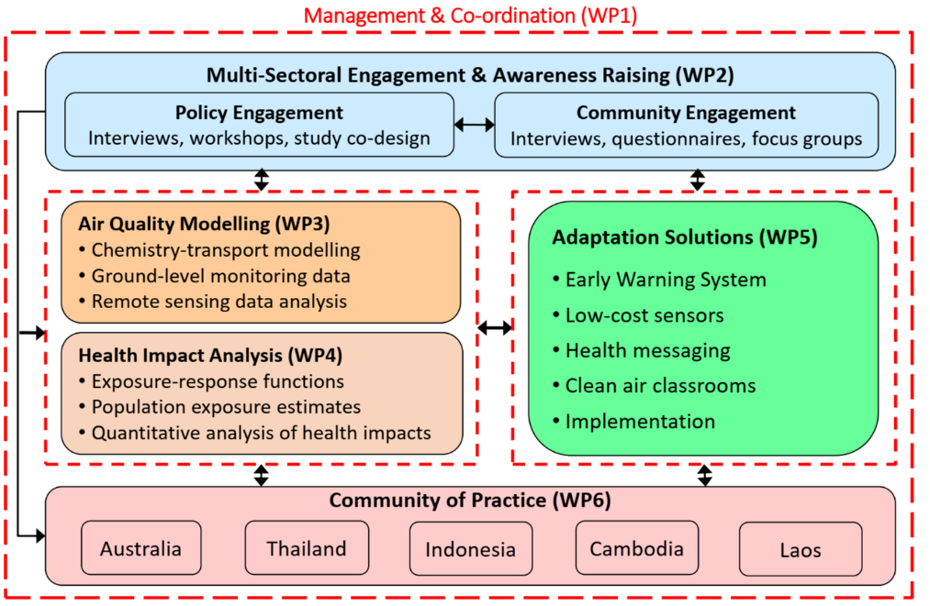
WP2: Multi-Sectoral Engagement
Task 2.1 Policy Engagement
- Systematically map relevant climate change adaptation, smoke haze prevention, and health
protection policies and interventions for children in Southeast Asia, as well as policy stakeholders in affected regions in Thailand, Indonesia, Cambodia, and Laos.
- Conduct in-depth interviews with key policy-makers from the Ministries of Health, Education, and Environmental Protection and four policy workshops, to prioritize adaptation solutions for affected communities and schools, identify implementation challenges, and co-design interventions.
Tasks 2.2 Community Engagement and Awareness Raising
- Use a cross-sectional mixed methods approach to assess community perceptions of climate change and related impacts of wildfires and smoke haze on children’s health.
- Determine environmental health literacy needs, and the understanding and acceptability of adaptation measures, such as early warning systems, low-cost sensors, and clean air rooms.
- Use FGD and the survey questionnaire will assess the perceived effects of smoke exposure on children’s
physical and mental health, including respiratory symptoms, stress and anxiety, cognitive function, and acceptability of health protection measures, such as health warnings and clean air rooms.
WP3: Air Quality Modelling
- To assess transboundary, regional and local air quality, the Weather Research and Forecasting (WRF) model coupled with selected chemical transport models (CTM), i.e., CMAQ, and Chem/CAMx.
- Quantify emissions from all major anthropogenic sources, including biomass open
burning based on well-established emissions inventory methodology.
- Evaluate the performance of modeling results using ground-based data.
- Assess future air quality for future climate conditions and various emission control scenarios that will be developed following the national roadmaps.
WP4: Health Impact Analysis
- Conduct quantitative health impact assessments (HIA), including uncertainty analysis, to
estimate: (a) the health burden attributable to current smoke haze in Southeast Asia using high spatial resolution air pollution maps (WP3), appropriately aggregated baseline health and population data, and air pollution and health concentration-response functions (CRF) for a range of health outcomes from the literature.
WP5: Evaluation of Adaptation Solutions
Task 5.1 Early Warning System
- Develop an automated meteorological classification using regional weather station
data from Northern Thailand to successfully predict smoke haze in Chiang Mai.
- Develop health messaging and exposure reduction advice for smoke haze episodes
of different intensities and durations targeted to children.
Task 5.2 Clean Air Rooms
- To assess the effectiveness of these interventions, we will evaluate smoke exposure in 20 nursery rooms in Chiang Mai (Thailand), and 20 classrooms in Palembang (Indonesia) over the smoke haze season.
- Monitor, including indoor and outdoor air quality (PM_{2.5}, PM₁₀), temperature, and relative humidity, and conduct semi-structured interviews with teachers, students and parents, and manual record classroom structure (e.g. size, doors, windows, and other openings), occupancy (e.g. number of students), and compliance with the intervention over time to estimate students’ exposure reduction.
Task 5.3 Implementation of interventions
- This implementation process will be informed by in-depth interviews and workshops with policymakers and community leaders (Task 2.1), surveys and FGDs with school communities, and ongoing engagement with local, national, and international organizations and potential funders.
WP6: Community of Practice
- Work collaboratively to strengthen research capacity and capability in key areas.
- Establish an online HEAL-HAZE Community of Practice, expanding on the Australian HEAL Network online platform and effective methods for sustained cross-sectoral policy and community engagement.
- Develop and deliver online training materials and webinars.

Key Deliverables/Activities/Achievements:
Template: Name of event/deliverables. Date. Place. Link with the events.

- Events
- Field trips/visits
- Publications
- Media
- Others

Events
Name | Brief Info | photo | Date. Place. Link with the events
Field trips/visits
Name | Brief Info | photo | Date. Place. Link with the events
Publications
Name | Brief Info | photo | Date. Place. Link with the events
Media
Name | Brief Info | photo | Date. Place. Link with the events

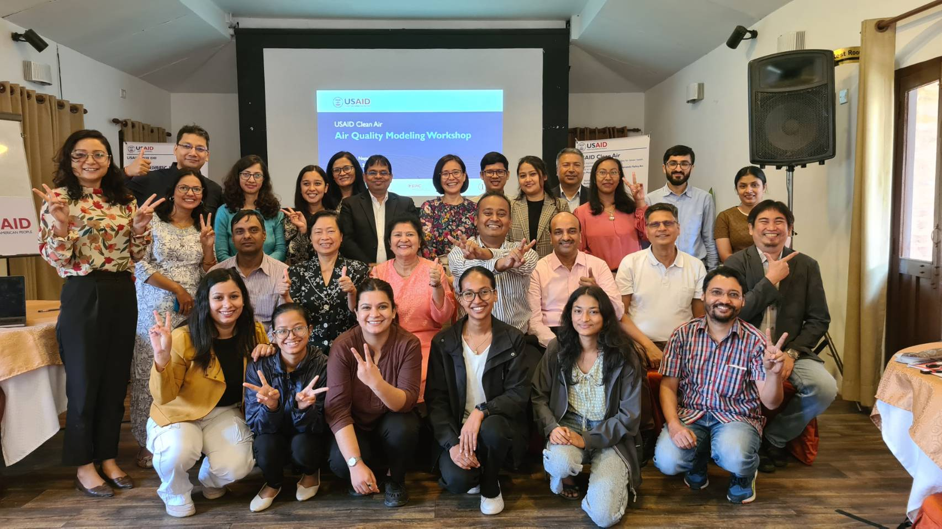
USAID Clean Air (K-CAP or Swachchha Hawa)
Funding: U.S. Agency for International Development (USAID) | Duration: 2022-2025
Partners: Family Health International (FHI 360), Air Quality Nexus Center (AirQC) at the Asian Institute of Technology (AIT), Energy Policy Institute at the University of Chicago (EPIC), Environment and Public Health Organization (ENPHO), and One to Watch (OTW).
Objectives: USAID Clean Air is a five-year initiative (November 8, 2021–November 7, 2026) that aims to improve air quality in the Kathmandu Valley to approach national ambient air quality standards, leading to improved health and educational outcomes.
The main objectives of the projects are to:
- Improve GoN capacity at all levels and willingness to drive evidence-based policy formulation, enforcement, and implementation that influences air quality.
- Improve civil society and citizen engagement and knowledge on air pollution issues to advance public interest and GoN and private sector accountability for improving air quality.
- Enhance private sector involvement and investment in addressing air pollution issues.
USAID Clean Air Framework
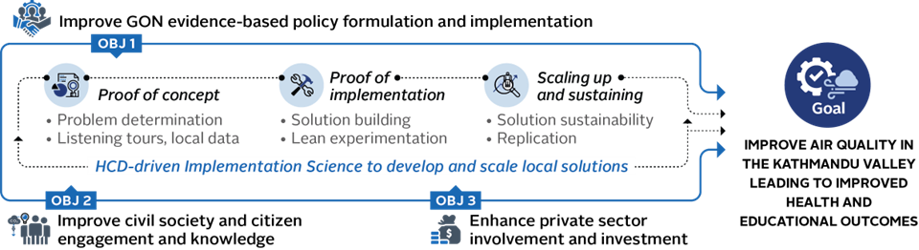

Core Activities of AirQC:
1. Providing technical guidance to assess and strengthen existing air quality data management and sharing systems in Kathmandu Valley (KV)/Nepal;
2. Supporting data compilation and analysis on air pollution in program areas to inform program priorities and interventions;
3. Develop a workable emissions inventory (EI) calculator, provide EI data, and build air quality modeling capacity;
4. Potentially using existing data from outside KV/Nepal to account for transboundary air pollution (some key sources of air pollution could be from outside of the KV);
5. Supporting the establishment of a consortium of scientists, researchers, and policymakers focused on atmospheric research in Nepal;
6. Holding workshops/training to address identified capacity gaps, particularly for enabling improved and quality evidence generation and use.
Major Achievements led by AIT:
1. Publication of the final peer-reviewed technical report “State of Air in Nepal with focus in Kathmandu Valley”, or SoAR report. It is accessed at https://zenodo.org/records/13335444.
2. Critical analysis of ambient air quality monitoring data. The results were included in the SoAR report and presented at different workshops and CARN (Consortium for Atmospheric Research for Nepal) meetings.
3. Development of an Excel-based workable calculator/model of emissions inventories (EI) for KV. EI results for the base year 2019 were presented at the CARN meeting. AirQC also provided the template and instructions to the Department of Environment (DOE) officers in the 6th training in Kathmandu in November 2024. The template was used by four Master’s students at local universities in Nepal to estimate emissions from key sources in KV for the year 2023.
4. Application of the air quality modeling system for analysis of air pollution in KV. Two Master’s students, jointly supervised by AirQC and Tribhuvan University (TU), have done research on modeling approaches.
5. Performance evaluation of low-cost sensors for air quality monitoring in KV and Nepal. One Master’s student, jointly supervised by AIT and TU, conducts research on this research topic.
6. Within AIT-CARN, we proposed receptor modeling for source apportionment of PM_{2.5} and particle-bound polycyclic aromatic hydrocarbons in KV using a full year of measurement data (2024-2025). A Ph D student was recruited to conduct the research on the topic and collected air samples for chemical analysis and source apportionment.
7. Road dust samples collected for silt content determination, which is required input for road dust emissions calculation for KV.
8. Establishment of CARN with 5 meetings (222 participants/105 females).
9. Co-organization and key training personnel for seven capacity-building programs for local stakeholders of Nepal on air quality management (203 participants/103 females).
10. Co-organization of four workshops on different topics related to air quality management (205 participants/99 females).

Events
Name | Brief Info | photo | Date. Place. Link with the events
“Consortium for Atmospheric Research of Nepal (CARN)” | Established the “Consortium for Atmospheric Research of Nepal (CARN)” within the USAID Clean Air framework with the support of local organizations and experts in Kathmandu Valley (KV). The Consortium aims to create and strengthen a network among the air quality and atmospheric researchers in Nepal to timely provide science-based information for policy making to effectively improve air quality in the country.  The involvement is on a voluntary basis and includes:  • Researchers from local universities, research organizations, and the private sector;  • Technical staff and policymakers from the national and local governments dealing with air pollution problems;  • International researchers who have profound experience in atmospheric research in Nepal and beyond.  Totally, five CARN meetings were organized in KV during Apr 2023 – Jan 2025, with the active participation of different stakeholders (academia, government, NGO, etc.). The 1st CARN meeting was on 4 Apr 2023 (total 59 participants/24 females), the 2nd CARN meeting on 11 Jul 2023 (total 20 participants/8 females), the 3rd CARN meeting on 13 Oct 2023 (total 33 participants/17 females), the 4th CARN meeting on 12 Apr 2024 (total 24 participants/15 females), and the 5th CARN meeting on 13 Nov 2024 (total 86 participants/41 females). | 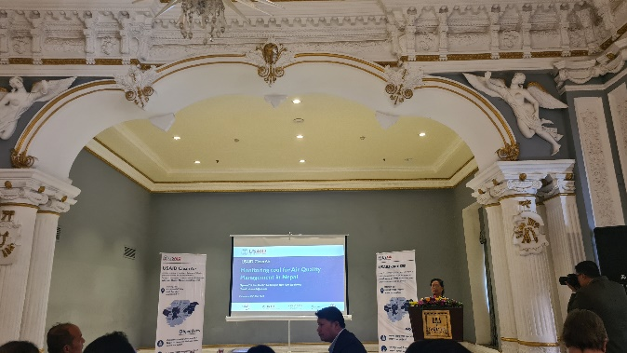  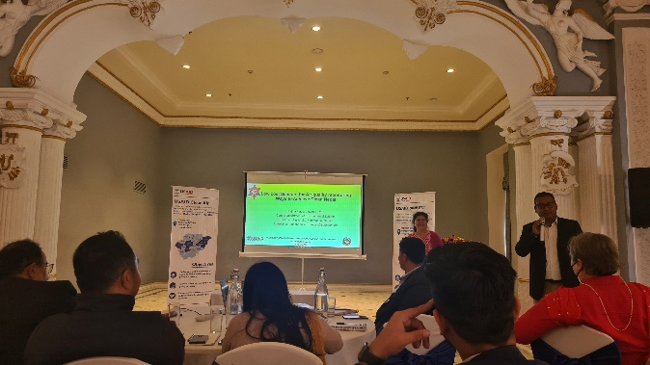  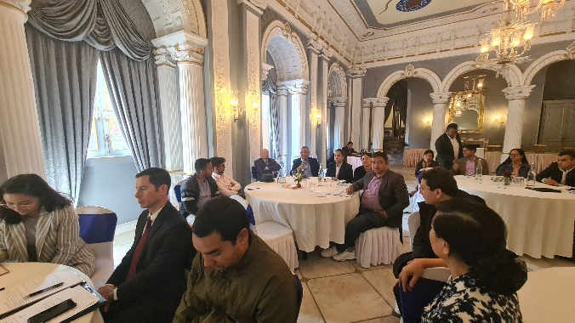  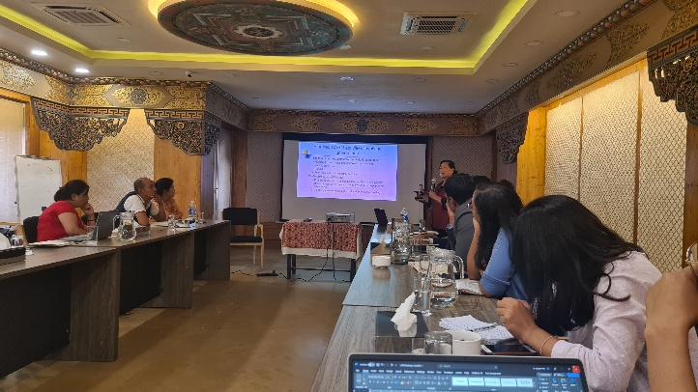  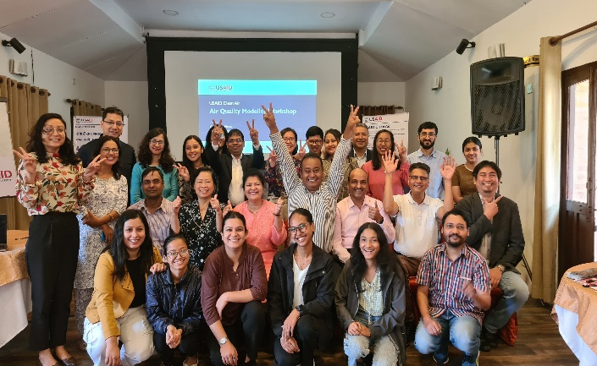  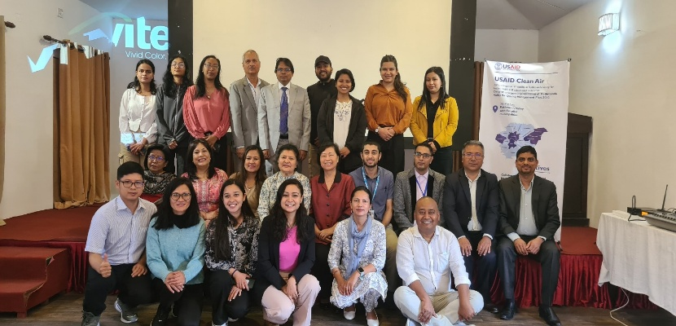  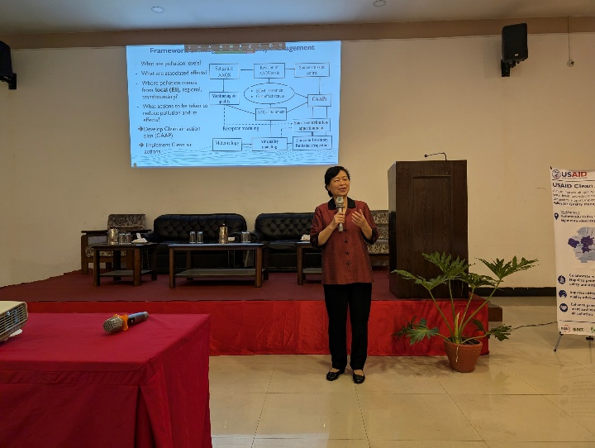 | 4 Apr 2023
Training Workshops by the Asian Institute of Technology within the USAID Clean Air | The AIT team supports strengthening the local capacity by co-organizing different training programs for stakeholders of Nepal on different aspects of air quality management (emission inventory development, receptor modeling, statistical sampling design, air quality modeling, PM_{2.5} monitoring, air quality monitoring, and development of the Clean Air Action Plan). In total, five wide-audience capacity-building and two focus-audience hands-on training programs were proposed by AIT, co-organized with the local USAID Clean Air team during Apr 2023 – Nov 2024, with a total number of participants of 203 (103 females, sharing 51%). The AIT experts played important roles as the key training personnel of these training workshops. An online evaluation form was delivered before and after each wide-audience capacity-building training workshop. Based on the evaluation of the participants from all wide-audience capacity-building training workshops, the knowledge, understanding, and skills of the participants for different aspects of air quality management were improved substantially after the workshops. | 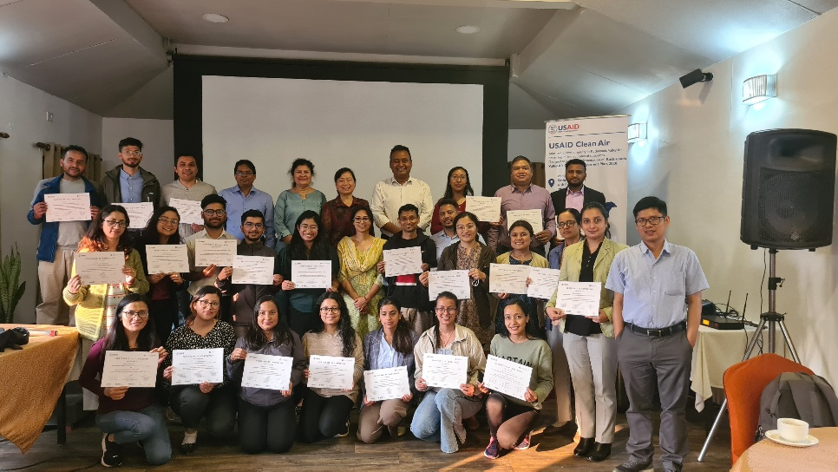  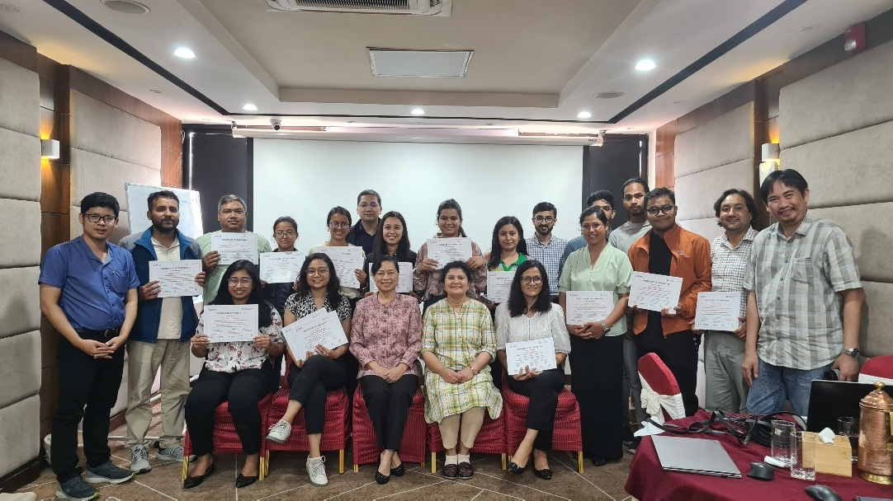  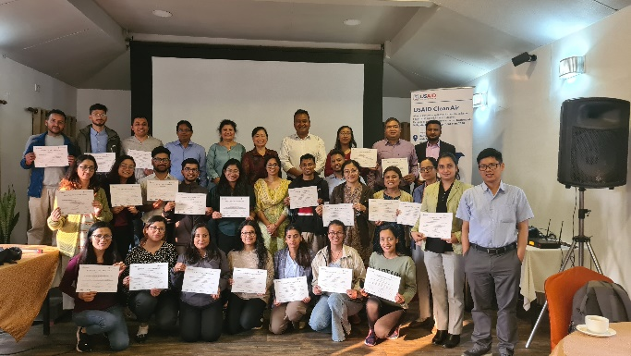
Field trips/visits
Name | Brief Info | photo | Date. Place. Link with the events
Publications
Name | Brief Info | photo | Date. Place. Link with the events
State of Air for Nepal with the focus in Kathmandu Valley | A comprehensive technical report led by the AIT team, published as part of the 5-year USAID-funded Clean Air project consortium. This assessment provides science-based evidence for Nepal to tackle air pollution problems through appropriate clean air measures. The report analyzes multiple data sources including ground-based and satellite monitoring, emissions inventories, model simulations, and reanalysis data, with a focus on PM2.5. Reviewed by recognized experts both inside and outside Nepal, including the Department of Environment. | 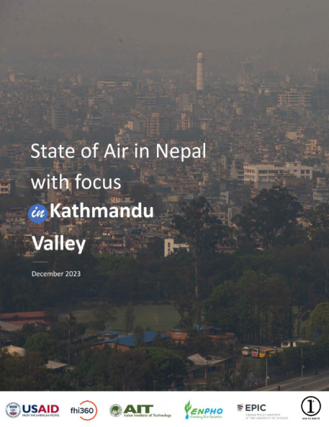
Media
Name | Brief Info | photo | Date. Place. Link with the events

Gallery:
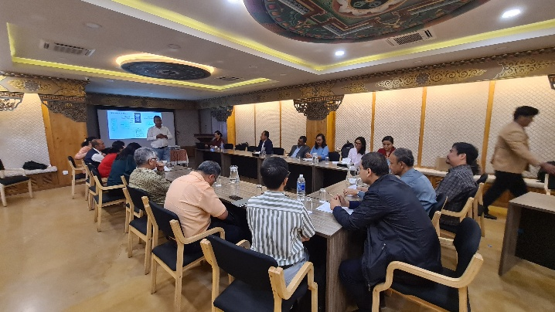 | 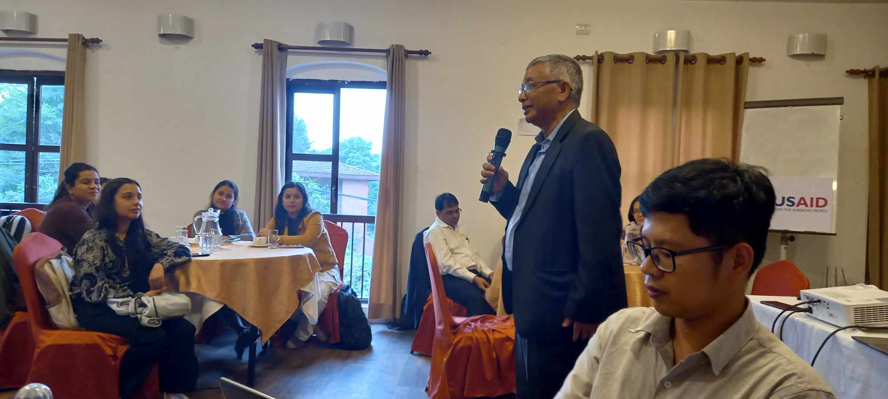
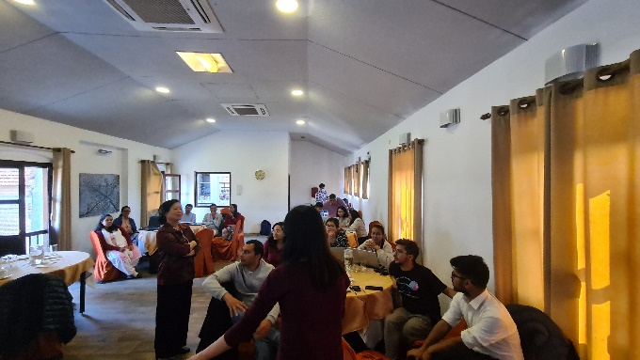 | 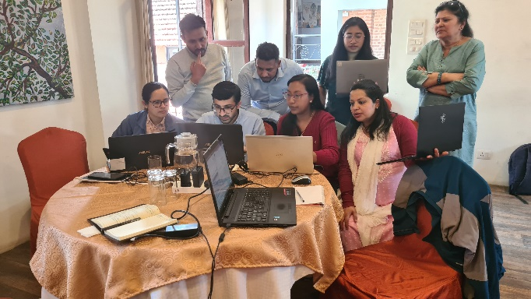
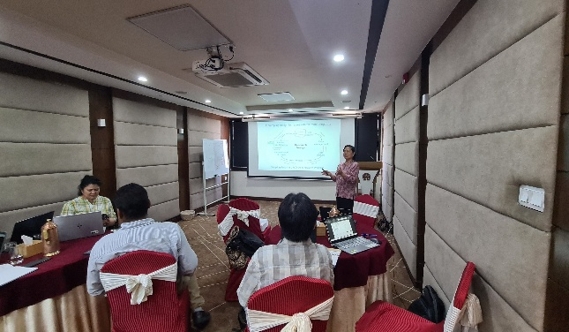 | 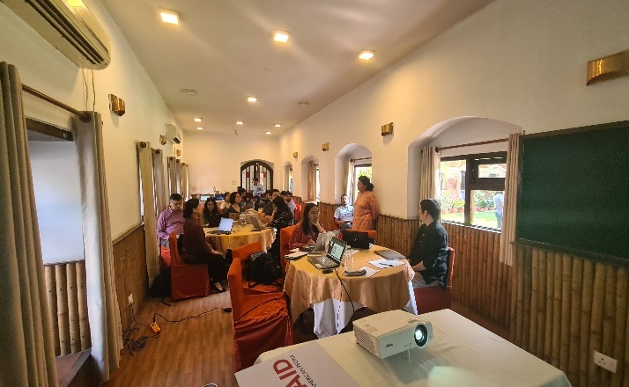
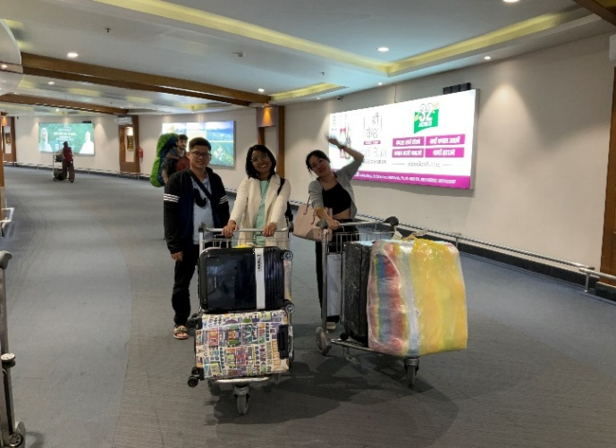 | 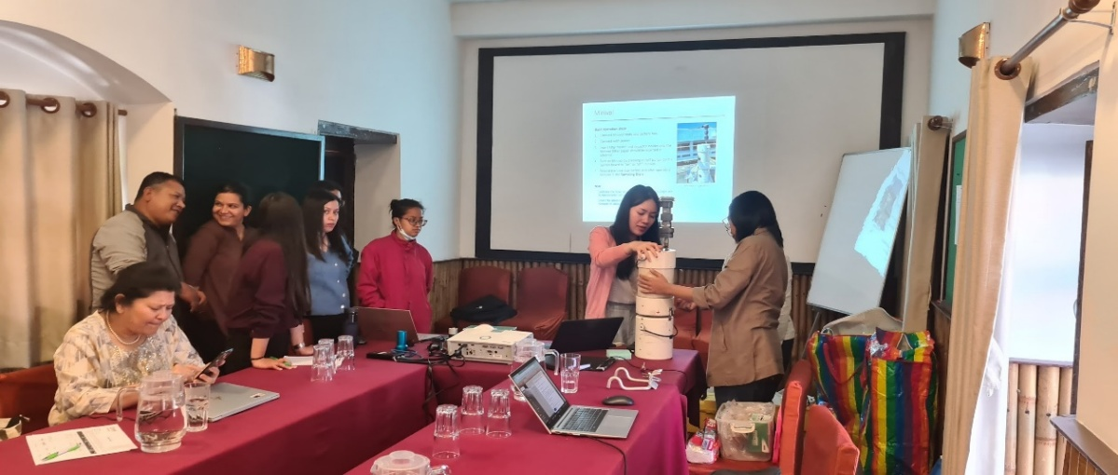
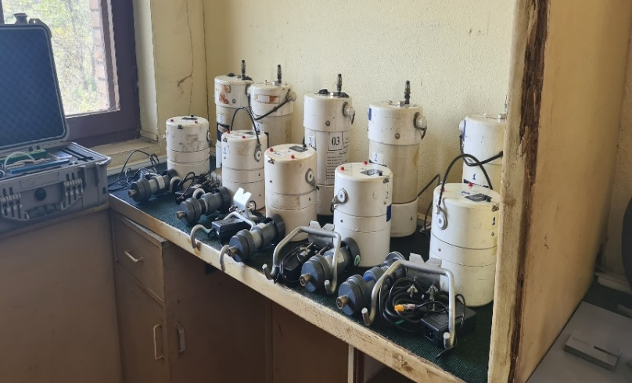 | 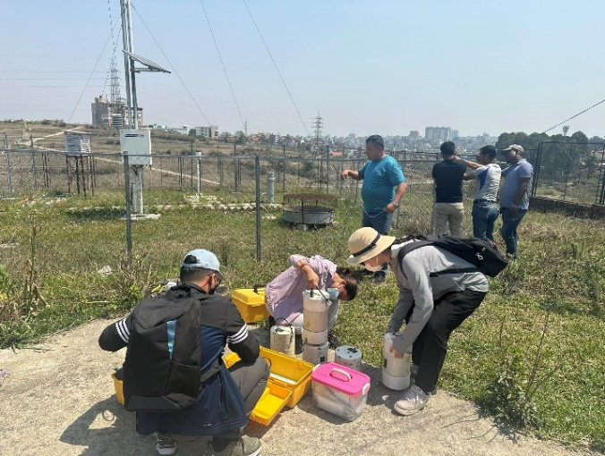
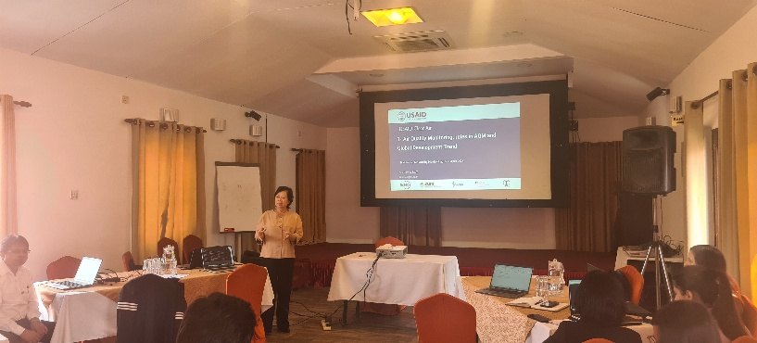 | 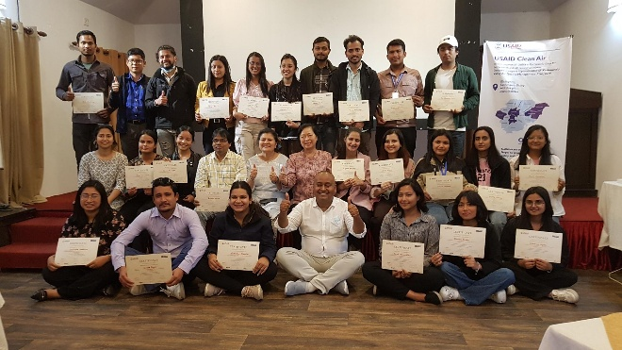
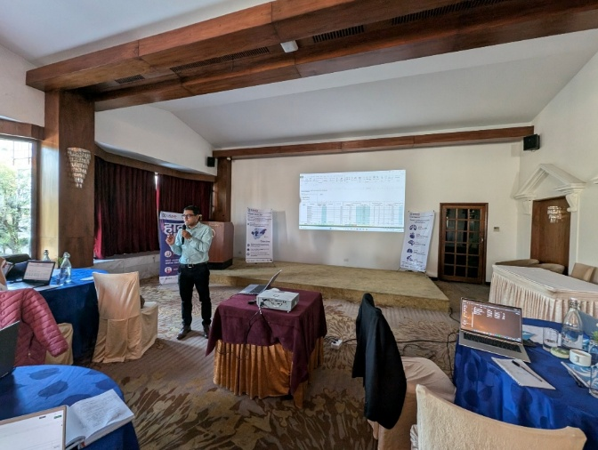 | 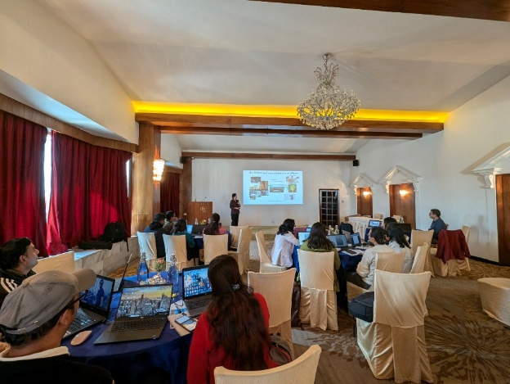

Regional Workshop “Mitigation Potential of GHG Emissions from Open Waste Burning under Present and Future Scenarios: Cases of South Asian Countries – Nepal and Bangladesh”, jointly organized by the Center of Research for Environment, Energy and Water (CREEW), Nepal; University of Dhaka, Bangladesh; and Kobe City University of Foreign Studies, Japan, with support from the Asia-Pacific Network for Global Change Research (APN): AirQC’s Director participated virtually as an invited expert and delivered a talk and comments on air quality and climate implications of waste burning, contributing to discussions on policy development and regional cooperation,1 Aug 2025

The truth about co-benefits: a multidimensional feasibility assessment for Thailand and beyond.
Publication category: Journal Article

Published Year: 2025
Authors: Zusman, E., Akahoshi, K., Hanaoka, T., Malley, C. S., Wangwongwatana, S., Onmek, N., Paw-armart, I., Kim Oanh, N. T., Huy, L. N., Kuylenstierna, J. C. I.
Journal Title, Volume (Issue), Page: Environmental Research Communications, 7(2), 025009.
DOI: https://doi.org/10.1088/2515-7620/adae5e
Cite: ‘’ Zusman, E., Akahoshi, K., Hanaoka, T., Malley, C. S., Wangwongwatana, S., Onmek, N., Paw-armart, I., Kim Oanh, N. T., Huy, L. N., Kuylenstierna, J. C. I. (2025). The truth about co-benefits: a multidimensional feasibility assessment for Thailand and beyond. Environmental Research Communications, 7(2), 025009. doi:https://doi.org/10.1088/2515-7620/adae5e

State of Air for Nepal with the focus in Kathmandu Valley
Publication category: Technical report

Published Year: 2023
Authors:

DOI: https://zenodo.org/records/13335444
Cite: ‘’ Zusman, E., Akahoshi, K., Hanaoka, T., Malley, C. S., Wangwongwatana, S., Onmek, N., Paw-armart, I., Kim Oanh, N. T., Huy, L. N., Kuylenstierna, J. C. I. (2025). The truth about co-benefits: a multidimensional feasibility assessment for Thailand and beyond. Environmental Research Communications, 7(2), 025009. doi:https://doi.org/10.1088/2515-7620/adae5e
LINK: AIR QUALITY IMPROVEMENT PROGRAM in THAILAND (AQIP) - Roadmap Emission Sources and Policies Report


For our thematic areas, I plan to use these:
High-quality interdisciplinary research
International Collaboration
Government Assistance
Capacity Building

